Must have in your handbag while you travel –
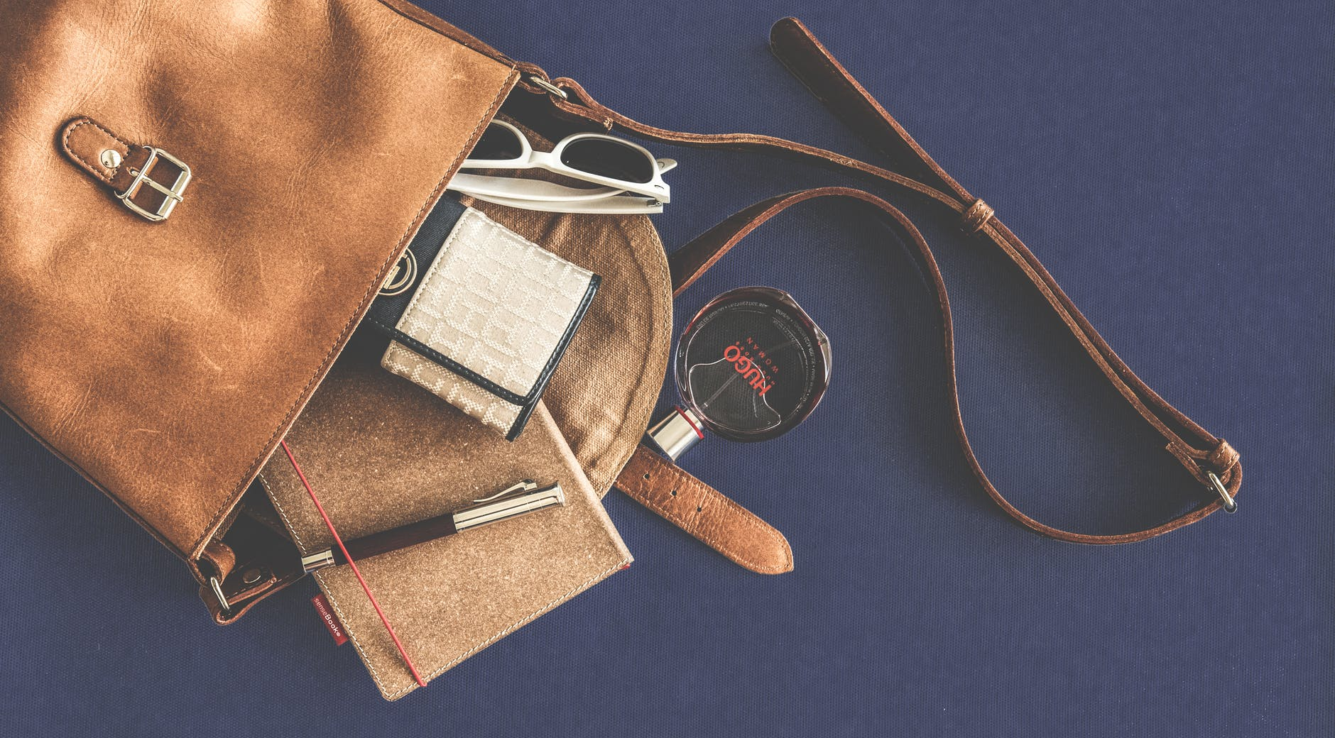
Are you planning to go on some vacations? Confused about what all you should keep in your handbag? Want to keep your important stuff handy but at the same time don’t want to unnecessarily make your handbag heavy? Are you traveling by air and the weight of your handbag is really a matter of big concern?
Take a chill pill. We are here to make your life more sorted with the perfect tips about some of the most important things that you should keep in your handbag right away. Just sit back and read our blog till the end and make a note of all these things so that next time you don’t have to think much about what to keep in your amazing handbags. Tighten your seat-belts and read till the end to explore what all is really required.
Sanitizer – A hand sanitizer is something very important to keep in our handbags. While traveling we touch so many public properties and things which comes in our way such as those auto handles, some window bars and doors at the airports or on trains, etc. Apart from this, pollution on the streets also adds germs in our hands. So, we require that perfect sanitizer to cleanse our hands as we can’t just access soaps and water everywhere and that too instantly. So, keep this instant to use sanitizer handy so that you keep your hands clean and keep those disease-causing germs away from you. Good hygiene helps in maintaining good health.
Band-aid – At times, due to traveling in a hurry or because of someone else’s mistake we often encounter certain sharp things which poke into our hands or legs or somewhere in our body. We need to keep the band-aid for such times. This will save us from that septic which could otherwise spread in our body and also keeps away germs from coming in direct contact with our wound and worsen it. Keep some 4-5 band-aids in your handbag so that they can act as your savior as and when they are required.
Tampon or Sanitary Napkins – You never know when that time of the month occurs prior to the original dates. When we travel than at times, due to exertion or lot of strain, our dates occur earlier than expected. Keep your tampons ready for that moment and also, you never know if you encounter someone else facing any such issue then you can at least help them by offering them that extra tampon or sanitary napkin that you carry in your handbag.
Hygiene Tissues, Handkerchief, and Hand towel – You must be thinking that when we already have sanitizer then why we require hygiene tissues? Sanitizer will just sanitize your hands whereas hygiene tissues can be used as wet wipes for your face or to remove that stain from your cloth and wipe out dirt. On the other hand, hand towels are still required because in case you get wet in rainfalls or maybe around some waterfall, then these will only dry you well. Also, that handkerchief apart from wiping out sweat can also be used to tightly wrap around that deep wound until the first aid is being provided or to wrap around your footwear in case it accidentally go out of function until you find out some cobbler or buy a new pair. It’s a weird but practical advice.
Perfume or Deodorants, Sunscreen, Moisturizer, Safety pins, and Comb – Those long and hectic trips often make us so tired and continuous traveling also make us come in contact with variable environmental conditions. This indeed makes the skin get dried. Also at times, due to sweat and all, our body starts to sting a little. Use your deodorants and perfumes for escaping those embarrassing moments. Also, in case your clothes get accidentally torn a little due to getting stuck somewhere then you should have those safety pins to fix that, until you can change that garment.
Pepper Spray – You never know when those unwanted elements start to follow you for money or for just troubling you. Keep the pepper spray handy to help you fight well and get rid of any such trouble. After all, nobody wants to take back a bad memory from their most awaited trip. Pepper spray will keep you safe and hearty.
Bottle, Candies and Chewing Gums – At times, due to so much traveling and exertion we feel like nausea especially in planes or while traveling to any hill station by road. Those candies and chewing gum will maintain that perfect pH of your mouth to avoid any such obstacle in your trip. Whenever you feel like nausea grab a candy or a gum.
Goggles, A thin but warm stole, and an Umbrella – Too much exposure in the Sun often make our eyes red so use that perfect pair of goggles to save your beautiful eyes so that you can enjoy all the views around you. Also, at times the temperature of an air-conditioned room doesn’t suit your body. So, keep that thin and warm stole to prevent you from catching a cold.
Brush – It may appear funny, but the toothbrush is a must to carry in your handbag. Sometimes, you just try some new thing or even something by chance enters your mouth and you feel like nausea. Keep that toothbrush to clean your mouth instantly by accessing the nearby washroom. After all, you need to keep your mood intact to enjoy your trip well.
Wallet - Keep your money in a zipped wallet so that you can easily access it as and when it is required. You can’t just afford to keep your wallet anywhere else than your handbag. While you are traveling, your pocket is not that safe place for you to keep your money.
Mobile phones, Portable adapter, and A Charged power bank – In today’s world mobile phones are a must. Our own people almost consider us dead if we are out somewhere and don’t pick their phone calls. Funny but true for most of us. Isn’t it? So, carry those power banks and adapters to keep your phone always charged. So, that you don’t have to take unnecessary tensions about charging your low batteries.
A pen and tiny diary – Maybe, you need to ask the locals about some of the nearby interesting places and the way Google maps suggest you reach that place is long broken. Then you need a pen and paper to note down those local ways to reach your destination.
Headphones – Your bae for the way, your headphones. No trip is complete without listening to songs on the way. Those long and often boring journeys especially when you are not feeling sleepy and everyone else in your group has slept or even when you are traveling alone, then all you require is your headphone and tune in to your favorite song. Say a goodbye to your boredom and enjoy the track.
We hope that you really liked our tips about what all is required by you to keep in your handbags. Share this post with your friends and family members and let’s just spread this piece of information to ease every woman’s life. We understand that you have too much to take care of, so we are here to manage such pity issues for you and make you release your unnecessary stress. Let’s all join hands together to spread this great blog and make every woman feel light. Just concentrate on managing other important stuff while we are busy exploring tips to enhance your traveling experience. Above all, keep your handbags organized to make you search everything easily and to enhance those elegant looks.